Documentation Building

Playful

Worlds 2

Natalia Skrzypiec

**Inspiration**

For the inspiration I chose two those two pictures, to me they have they same kind of feeling of portal/doors to another world, but from different perspectives. From dark to light, just different color palette and textures.

After a while I started to think that I may have chosen those pictures because they both are mysterious, but not particularly dangerous. So in my head automatically popped the Void.

Pictures I chose:

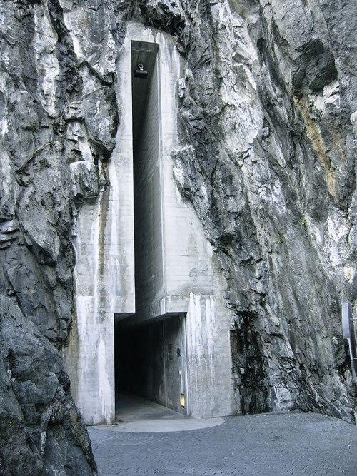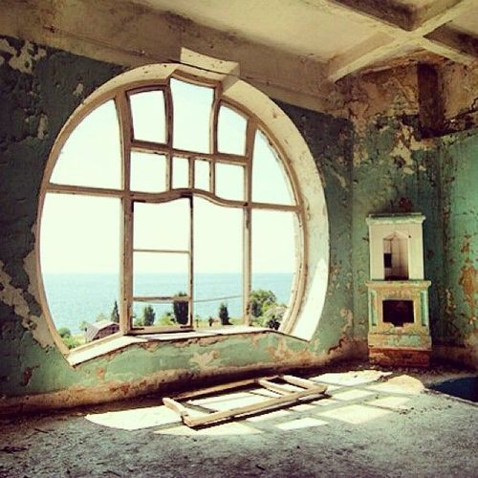

Moodboard :

My main inspiration was design from Dishonored 2, with the same aspects, I took the part where they mix sharp and soft edges on black stone, I saw similar pattern in the game Dagon and it has been somehow stuck in my mind. I am also in love with elegant black pieces like textile and stones.

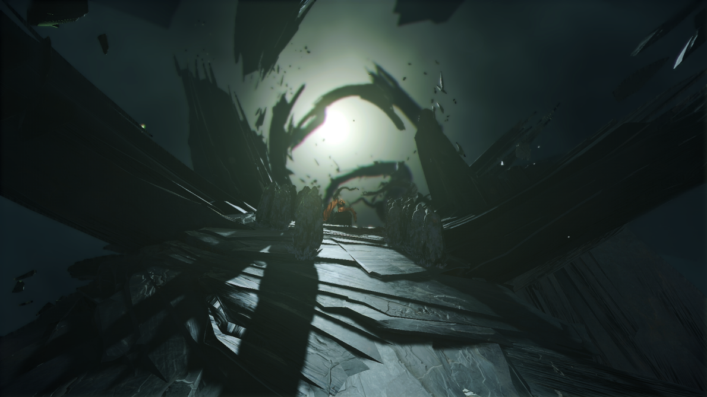

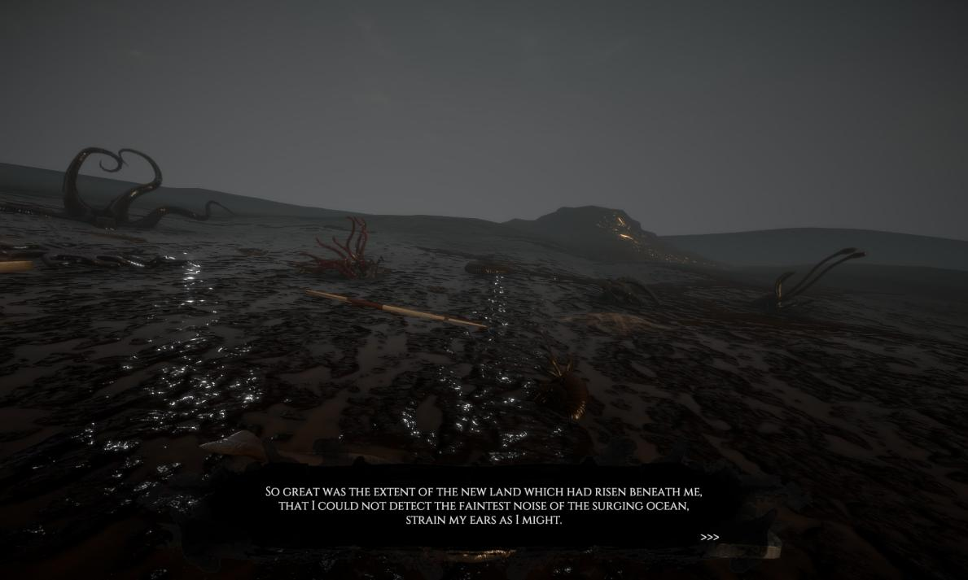

Storyboard

I wanted for player to find himself in the beginning alone and not knowing where he is but also not in danger. I wanted to create feeling of melancholy in a kind of spiritual place. Mirror was suppose to be a metaphor for trying to find yourself (also mirror is a nice metaphor for door), but there also other hidden symbols such as platforms in the shape of Flower of Life or Spider lilies that represent death.

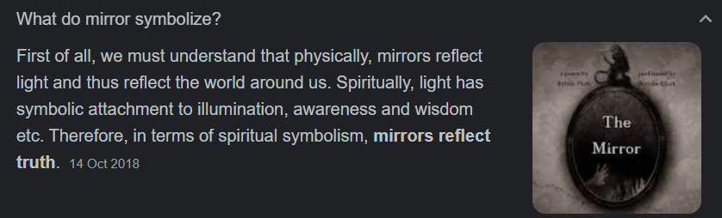

So once you leave your void, where is nothing and no one, you will die. Kind of ironic but also trying to tell that someone can be stuck between two worlds because neither of them feel safe enough, yet you have to be there: a world where you are on your own and a world with people around you, no matter what relationship you have with them.

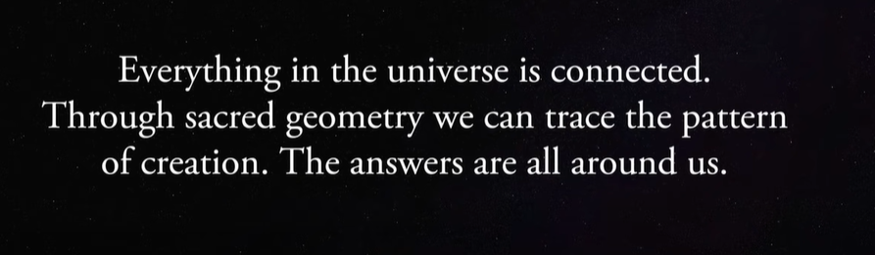

<https://mythcrafts.com/2020/01/23/lycoris-radiata-the-japanese-hell-flower/>

Used assets

My assets

Tutorials

Mirror:

<https://www.youtube.com/watch?v=U9yTnRuU--A>

Respawn:

<https://www.youtube.com/watch?v=tB_ihytqGpo&t=297s>

Camera Shake:

<https://www.youtube.com/watch?v=9A9yj8KnM8c>